ESS New Automation Model – Phase 1

Document Control
Process | Name | Title | Date
Authored by | Webber Ling | Team Lead, Quality Assurance | May 5, 2012
Approved by

Revision History
Date | Version | Description | Author
May 5, 2012 | 1.0 | Initial version | Webber Ling

ESS New Automation Model – Phase 1
Table of Contents

1. INTRODUCTION - 3 -
1.1 ESS NEW AUTOMATION MODEL – PHASE 1 - 3 -
1.2 Topics to be covered - 3 -
2. Overall schedule of New Automation Model – Phase 1 - 3 -
2.1 Description - 3 -
2.2 Tasks to be completed in phase 1 - 3 -
2.3 Milestones - 4 -
3. Automation tools to be applied in this new model - 5 -
3.1 DESCRIPTION - 5 -
3.2 Introduciton of candidates - 5 -
4. Initial structure of new automation model - 6 -
4.1 DESCRIPTION - 6 -
4.2 High-level structure - 6 -
4.3 Automation core component sturcture - 7 -
5. POC of the new automation model - 8 -
5.1 Description - 8 -
5.2 Simple model (google searching) - 8 -
5.3 Complex business model (BA2 real testing case) - 8 -
5.4 Pass/Fail criteria - 8 -
6. Training Efforts and Schedule - 8 -
6.1 Description - 8 -
6.2 Basic training - 9 -
6.3 Advanced training - 9 -
6.4 Training Schedule - 9 -
7. Responsibilities and Risks - 10 -
7.1 Responsibilities - 10 -
7.2 Risks - 10 -

ESS New Automation Model – Phase 1

INTRODUCTION

ESS NEW AUTOMATION MODEL – PHASE 1
This document outlines the initial phase of ESS new automation model (Selenium based) which will be applied as the replacement of current ESS automation framework based on HP Quick Test Professional. Due to the limitation of Selenium, this new model only applies to B/S applications. C/S applications keep using current ESS QTP Automation Framework.
All required schedules, tasks, efforts and outcomes in this phase will be defined in this document.

Topics to be covered
Topics covered in this document
- Overall schedule of New Automation Model - Phase 1
  - Tasks to be completed in this phase
  - Milestones (entry/exit criteria)
- Automation tools to be applied in this new model
  - Introduction of candidates
- Initial structure of the new automation model
  - High-level structure definition
  - Automation core structure definition
- Proof Of Concept of the new automation model
  - Simple model (Google search testing example)
  - Complex business model (BA2 real testing example)
  - Pass/Fail criteria
- Training efforts and schedule
- Responsibilities and Risks

Overall schedule of New Automation Model – Phase 1

Description
This section defines the overall schedule of ESS New Automation Model – Phase 1, including the tasks/efforts need to be carried out and finished in this phase. Milestones are defined in this section as well.

Tasks to be completed in phase 1
There are several tasks have to be completed in this phase because it is the initial phase of ESS new automation model, which is the very crucial one that all coming efforts and plans will based on the outcome of this phase. By completing the tasks defined in this phase decides the next step of this new automation model implementation schedule.
Task list
- New automation model structure definition
- Automation tools evaluation and finalization
- Proof of concepts with source codes
- Basic training materials
- Demonstration

Milestones
There are several milestones defined here to illustrate the progress of Phase 1.
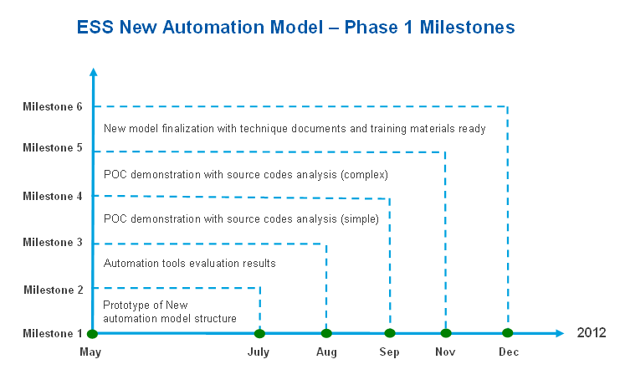
Milestone 1: Prototype of New automation model structure
Description:
In this milestone, a brief introduction of new automation model structure is defined
Due date:
Before July-2012
Outcome:
Technique document of new automation model
Milestone 2: Automation tools evaluation results
Description:
Since multiple candidates are available for the new model (Selenium IDE, RC, WebDriver, Java, Python, AutoIT, etc), an evaluation of these tools are required to finalize the tools to be used
Due date:
Before Aug-2012
Outcome:
Technique document of the tool analysis results along with source codes if available
Milestone 3: POC demonstration with source code analysis (simple)
Description:
Poof of concept using a simple test case under this new automation model
Due date:
Before Sep-2012
Outcome:
Demonstration of the POC along with source codes
Milestone 4: POC demonstration with source code analysis (complex)
Description:
Poof of concept using a complex business model test case (BA2) under this new automation model
Due date:
Before Nov-2012
Outcome:
Demonstration of the POC along with source codes
Milestone 5: New model finalization with technique documents and training materials
Description:
The new automation model is finalized with all required technique documents and POC source codes and training materials as well
Due date:
Before Dec-2012
Outcome:
All new automation model related technique documents, source codes and training slides/docs/videos
Overall, the ESS New automation model will be constructed and finalized by end of 2012 with all milestones achieved.

Automation tools to be applied in this new model

DESCRIPTION
This new automation model is Selenium based model, due to the limitation of Selenium, third-party IDE must be used to assist Selenium RC or WebDriver codes.
For Selenium itself, two versions of export are available, Selenium RC and Selenium WebDriver.
Selenium RC was proved to be good and stable, however, no longer supported.
Selenium WebDriver, a new, promising version, but not fully completed with some limitations and improvements still in process.
Meanwhile, other third-party tool(s) will also be used on the purpose of providing comprehensive support to Selenium.

Introduciton of candidates
Based on currently automation experience in ESS and some initial investigation along with consideration of cost, there are several candidates are taken as top consideration, they are:
- Selenium IDE
- Selenium RC
- Selenium WebDriver
- Java (JUnit) with Eclipse SDK
- Python
- AutoIT
- TBD (depends on further requirements)

Initial structure of new automation model

DESCRIPTION
In this chapter, the structure of this new automation model is introduced at two levels:
- High-level structure
- Automation core component structure

High-level structure
Below chart describes the high-level structure of ESS New Automation model.
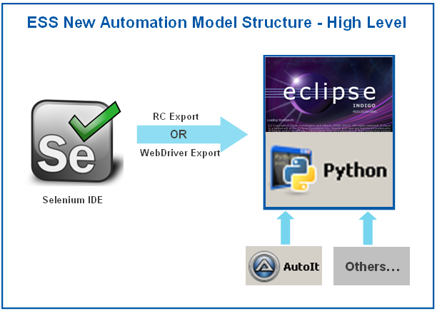
Basically, the overall structure includes two parts:
Part 1: Selenium related, including Selenium IDE and Selenium export, however, it is still a pending whether to use Selenium RC export or Selenium WebDriver export. It depends on the evaluation outcome in section 3.2.
Part 2: Third party platform (Java or Python), which used to integrate the Selenium exported codes with more complicated organization and control. Meanwhile other third part tools are implemented in part 2 as well as assistants.

Automation core component sturcture
In 4.2, an overall structure of this new automation model is illustrated, in this section, a more detailed structure is described which resides in Part 2 of 4.2.
The automation core component structure defines the framework to be applied in the third-party IDE to serve the purpose of professional automated testing.
Prior to this new model and till now, an ESS QTP Automation Framework (have been developed and well-maintained over 10 years) is shared across multiple projects, which have been proved to be a successful model in the past years.
The very basic idea of ESS QTP Automation Framework is by providing multiple function library layers for better modularization, hiding the complex implementation from the end user (entry level automation engineer), so the test script creation is maximally simplified along with the maintenance cost at a minimum level.
Because of this, the new automation model inherits the full advantage of ESS QTP Automation Model, although the implementation uses different technology.
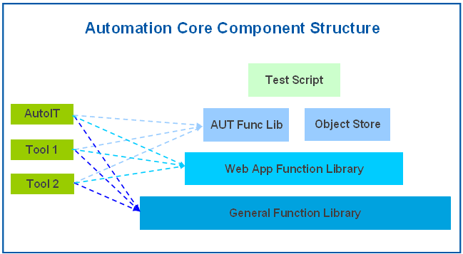
Automation Core Component Structure
- Level 1 (General Function Library): This is the bottom level function lib, it provides very basic and AUT independent function calls, e.g. string manipulation, IO operation, excel read/write, standard windows control manipulation, etc. This library is shared by all AUTs.
- Level 2 (Web App Function Library): This is the second level function lib and based on Level 1 which means it enjoys all functions/methods from Level 1. As its name, it provides all Browser, webpage related actions, including enclosure the common used function/method for standard web controls. This library is shard by all AUTs.
- Level 3 (AUT Func Lib & Object Store): This is the AUT specific layer and based Level 2, the whole framework only has one general function library and one web app function library while it will have multiple sets of AUT Func lib along with corresponding object store. Object store, which is called as object repository in QTP, provides shared objects through the whole AUT. AUT Func lib provides standard and modularized function call for the AUT to simplify the test script creation.
- Level 4 (Test Script): This is the top level of the framework and the most easy part because it is designed for entry level automation engineer, any automation engineer with very basic training is able to create test scripts by simply searching required function call in AUT Func Lib and combining them into test script(s).
Across layer 1 to layer 3 in this framework, the third-party tools support are always welcome for any layers by providing faster, better, more efficiency solutions.
BUT, third-party tools should NOT be put into layer 4 (Test Script), this layer is the top level which only need function calls from highly modularized layer 3, no complex codes implementation should be in this layer.

POC of the new automation model

Description
Proof of Concept MUST be done before formally establish this new model, any risk, potential issue and obstacle will be dressed out from POC phase.
Two Proof of Concepts will be carried out here, refer to section 5.2 and 5.3. And both of them will be carried out under both Java and Python platform as comparison for finalization at the final stage.

Simple model (google searching)
This is a simple POC model just including several steps on searching something in Google. However, except the automation core framework, all necessary recording, export, coding and third-party IDE will be involved to test the compatibility of these tools and to see how it works.
Output of Simple Model POC
- POC description and demonstration
- Evaluation document/slides with all necessary information
- Full package of source codes

Complex business model (BA2 real testing case)
This is a complex business model which use current ESS project BA2 as example, a typical BA2 testing scenario is provided as manual test step.
Output of Complex Business Model POC
- POC description and demonstration
- Evaluation document/slides with all necessary information
- Full package of source codes

Pass/Fail criteria
Both of two POCs should provide the PASS/FAIL as final result which follows below criteria:
- Ability: 100% of manual steps can be automated
- Liability: 100% of automation codes can be executed smoothly and repeatable with consistent output
- No outstanding issues

Training Efforts and Schedule

Description
Training is quite important for this selenium based automation model because it requires multiple technologies and development platform is involved as well.

Basic training
One is basic training which targets at entry level automation engineer to make them familiar with Selenium and third-party IDE, focus on building up knowledge of using this framework by calling functions to create/execute test scripts along with basic debugging skill.
The automation engineer finished Basic training session should:
- Record/improve Selenium IDE scripts comfortably
- Familiar and coding in third-party IDE
- Understand the AUT function library and fast locate function calls
- Create test scripts using third-party IDE
- Understand the whole model structure and library dependency

Advanced training
The other is advanced training which targets at experienced automation engineer in order to make them capable of developing, maintaining the automation framework, expanding, improving the function libraries, investigating third-party tools, introducing new technologies, etc.
The automation engineer finished advanced training session should:
- Well-understand and capable of all items required in basic training session
- Very familiar with third-party IDE and work with Selenium export codes comfortably
- Well-understand each function library layer and able to improve and maintain them
- Well-understand third-party tools and able to use them assist Selenium
- Able to support entry level automation engineers

Training Schedule
The training session itself is closely binding with the development of the framework, going through each milestone, corresponding training will be provided and particularly, it will keep going on and more focus will be put on after the framework is finalized.
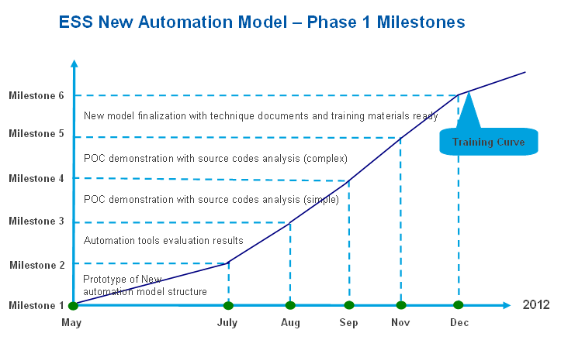
Above schedule defines the whole development of this new automation model and the training curve cross over all periods.

Responsibilities and Risks
During construction of this new automation model, the responsibilities and risks are considered as well.

Responsibilities
Webber Ling (ESS QA Lead) is the responsible person for this new automation model and any outstanding issues, obstacles which cause Block should escalate to William Tu (ESS QA Manager) as soon as possible.
Responsibilities
- Resource management – William Tu
- Review and milestone sign off – William Tu
- Process and Quality control – Webber Ling
- Technique solution – Webber Ling
- Demonstration and Training– Webber Ling

Risks
Since this is a whole new automation model, there must be some potential issues and unpredictable risks including technique issue, resource issue, etc. The responsible person should raise them out as soon as possible.
And there will be a heavily coding load particularly in creating the function library files (layer 1, layer2 and layer 3), additional resources will be required as well.

